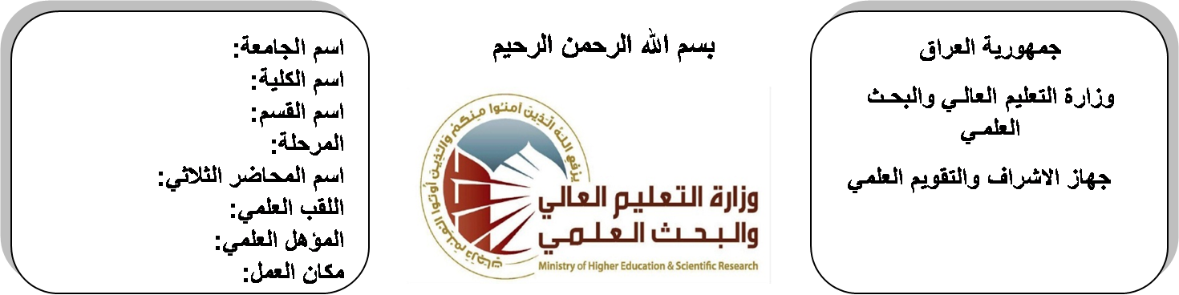

**Republic of Iraq**

**Ministry of Higher Education**

**& Scientific Research**

**University: Diyala University**

**College: College of Engineering**

**Department: Electronic Engineering**

**Stage: fourth**

**Lecturer name:Ahmed Mohammad**

**Qualification: M.Sc**

**Place of work: Electronic Dept.**

**(( Annual teaching plan form))**

|  |  |  |  |  |
| --- | --- | --- | --- | --- |
| **Lecturer Name** | **Ahmed Mohammad** | | | |
| **Email** | **AHMED_ZYDI@YAHOO.COM** | | | |
| **Subject** | Communication Systems | | | |
| **Aims** | **The aim of this subject is to make the students ready to undestand and comprehend the scientific theories and their applications related to their field of the study.** | | | |
| **Textbooks** | Anologe & Digital communications by HWEI, **HSU.** | | | |
| **Additional Textbooks** | **Communication systemsby Ferrel G.Stremler.** | | | |
| **Assessments** | **First Semester** | **Second Semester** | **Laboratory** | **Final Exam** |
| 20% | 20% | 10% | 50% |
| **Notes** |  | | | |

**Schedule Weekly Lessons - First Semester**

|  |  |  |  |  |
| --- | --- | --- | --- | --- |
| **Week** | **Date** | **Lectures** | **Lab. Experments** | **Notes** |
| 1 | **30/9/** | **Information Theory** |  |  |
| 2 | **7/10/** | Self information |  |  |
| 3 | **14/10/** | sourse entropy and sourse entropy rate |  |  |
| 4 | **21/10/** | mutual information |  |  |
| 5 | **28/10/** | channel model BSC and nonsymmetric discrete channels |  |  |
| 6 | **4/11/** | Optimum threshold setting |  |  |
| 7 | **11/11/** | Capacity of continuous channel(Shannon eq). |  |  |
| 8 | **18/11/** | Coding of Discrete Sources |  |  |
| 9 | **25/11/** | Efficiency and redundancy of a code |  |  |
| 10 | **2/12/** | fixed length codes |  |  |
| 11 | **9/12/** | variable length codes |  |  |
| 12 | **16/12/** | fano code, huffiman code |  |  |
| 13 | **23/12/** | Shannon code. Nonbinary source coding |  |  |
| 14 | **30/12/** | Source extention for higher coding efficiency. |  |  |
| 15 | **6/1/** | **Channel Coding** |  |  |
| 16 | **13/1/** | Even and odd parity error detecting codes |  |  |
| Half Year holiday | 15/1/ to  1/2/ |  |  |  |

**Lecturer Signature Head of Dept. Signature Dean Signature**

**Schedule Weekly Lessons - Second Semester**

|  |  |  |  |  |
| --- | --- | --- | --- | --- |
| **Week** | **Date** | **Lectures** | **Lab. Experments** | **Notes** |
| 1 | **17/2/** | prob of undetected errors. Error correcting codes |  |  |
| 2 | **24/2/** | linear block codes (generator and parity check matrices),hamming distance |  |  |
| 3 | **2/3/** | hamming weight bound, and error correction capabilities |  |  |
| 4 | **9/3/** | Decoding of linear block codes (syndromes). |  |  |
| 5 | **16/3/** | Cyclic codes: generator polynomial, nonsystematic code (multiplication) |  |  |
| 6 | **23/3/** | systematic cyclic code (division), and realization logic circuit for encoding logic and decoding of systematic cyclic codes |  |  |
| 7 | **30/3/** | Convolution codes,encoding logic (generation),tree diagram state diagram and trellis diagram of convolutional cod |  |  |
| 8 | **6/4/** | Block diagram of a general (DSP) system.  Basic concepts: linear, time variant, stable and casual discrete systems. Input/output relation in Z-domains |  |  |
| 9 | **13/4/** | Discrete convolution techniques: tabular method-transform method, matrix method, add overlap method. |  |  |
| 10 | **20/4/** | Deconvolution methods: iterative method and Z-transform method. Frequency response of discrete system |  |  |
| 11 | **27/4/** | Discrete Fourier transform (DFT),Fast Fourier transform (FFT) decimation in time. |  |  |
| 12 | **4/5/** | Review of analogue filters design (Butterworth and chebyshev filter) |  |  |
| 13 | **11/5/** | Classification and realization of discrete systems (FIR and IIR system ) |  |  |
| 14 | **19/5/** | IIR filter design using analogue filters and the bilinear transformation, filter transformation for IIR(LPF/LPF,LPF/HPF,LPF/BPF,LPF/BSF) |  |  |
| 15 | **26/5/** | FIR filter design using windows: Rectangular, Bartlett, hanning, hamming and Blackman windows |  |  |
| 16 | **3/6/** | LPF, HPF, BPF, and BPF, and FIR filter. |  |  |

**Lecturer Signature Head of Dept. Signature Dean Signature**